Austin’s Butterfly - Constructive Criticism - Terrace Town

Day 1 (15-20 min)
Watch Austin’s Butterfly video with class in its entirety: https://vimeo.com/38247060
Have a short discussion about what students noticed about the process, what their thoughts are (my students were in awe of what Austin created).

Day 2 (30 min)
Remind students of the Austin’s Butterfly video. Students can turn and talk: “What was one thing you remember about the video Austin’s Butterfly?” Key points to hit:
- Austin was in 1st grade, he picked a picture of a real butterfly and tried to draw it.
- His friends gave him feedback (constructive criticism) that was specific and kind/productive.
- Austin tried again and again and his drawing improved.
Discuss with students what constructive criticism is, defining it and why it can be helpful in a planning or drawing process. Draw connections to writing and peer editing, how can another person help you (i.e. they may have more knowledge, they may notice something you forgot, they may have another idea you haven’t thought of yet). You can chart these ideas if you’d like, so that you can add sentence stems on Days 3 & 4.

Day 3 (30 min)
Start by reminding students about constructive criticism and the definition you created. Ask students to share what they remember about how Austin’s classmates gave feedback about his drawing (they were nice, they were specific about what needed to be fixed/improved, they encouraged/gave positive feedback about what looked great). My students were able to paraphrase from the video, “They told Austin to fix the angle of the wings.” “They told Austin that he needed to add the right colors to his picture.” Tell students that today, you will be needing their constructive criticism to improve a drawing of yours.

Next, on the whiteboard, draw a simple shape or building. I decided to draw a rectangle with two circles to represent a car. I had it on the whiteboard since the beginning of the lesson and many students remarked, “What is that?” “What is that supposed to be?” So after the discussion, I said to the class, this is a car. Can you give me some constructive criticism to help me improve my drawing to make it more realistic?

I used Pick-A-Sticks to select students to share their thoughts. You might want to have students turn and talk to come up with some ideas with a partner first if you think they need practice. When students offer their advice, not only edit your drawing but also chart their words into sentence stems. For example, “Ms. Garnett, your car looks good but cars have a windshield and yours doesn’t.” Turns into “Your __________ is (positive feedback) but maybe you could add ____________________.” Or, “Instead of _______________ could you try __________________?” Or, “Based on what I know about __________________ there’s __________________.” Your kids will have some great ideas!
Connect to Terrace Town - How could we use this to help us with our town? (We could create sketches of our buildings and then make them come to life).

If there is time, have students begin a sketch of a building they are assigned to create for Terrace Town.

Days 4 & 5 (30 min)
Review constructive criticism and list of sentence stems. Give students a few minutes to work on their sketches. Next, have them work in pairs to share constructive criticism and make edits. Share out at the end and add any sentence stems/sentence starters that students use in addition to those already brainstormed. For example, “Thanks _________ for the advice. Are you ready for my constructive criticism?” Or “That’s all the advice I have right now, do you have any constructive criticism for me?” Or “Hmmm I’m not sure I know what you mean, like this?” Or “Thank you for your advice, I understand what you’re saying but I like that part of my building and don’t want to change it.”

Repeat for Day 5, students may work in a cycle of drafting, advising each other, revising and eventually beginning a draft of a new building. Each day ends with sharing of new discoveries and improvements across drafts.

Possible exit slip idea:

"Today, one piece of constructive criticism I received was ___________________. One piece of constructive criticism I gave to my partner was __________________. My next step is ______________."

Constructive Criticism
We watched the video Austin’s Butterfly and we learned about a first grader named Austin who wanted to make a realistic drawing of a butterfly. Austin made eight drafts in all, his final draft being his best!
After each draft, Austin’s classmates offered constructive criticism that was not only positive but specific to a part of the butterfly Austin could improve. Austin was persistent and returned to his drawing of the butterfly to make improvements.
We used this same process to draft drawings for our Terrace Town buildings. We worked in partner pairs to offer constructive criticism. Here were some of the sentence stems we found were the most helpful:
“Wow! I really like the ___________________ part of your building. Maybe you could add ________________________.”
“Instead of ________________, maybe you could try ____________________.”
“Based on what I know about _________________, there’s _________________.”
“What if you tried ________________________?”
You can watch Austin’s Butterfly by accessing the QR code on your smartphone.

https://vimeo.com/38247060
We hope it inspires you to try constructive criticism and drafting in your own classroom!
Giving Our Opinion

We used a bucket with tennis balls to learn how to form an opinion with supporting reasons. We wanted to share our opinions about what kinds of buildings and places we needed in our city.
Students sat in a circle and passed around the bucket. During their turn, a student would use the parts of the bucket and tennis balls to explain their opinion.

Lid – Introduction
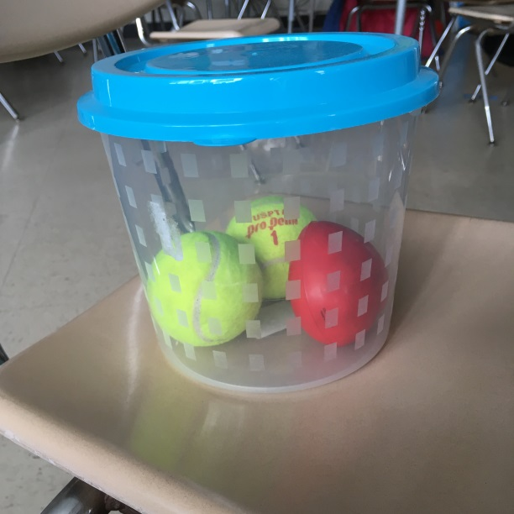
“We are building a city for Terrace Town. We need to decide what kinds of buildings and places we need in our city.”
Heart – In My Opinion
“In my opinion, I think we need a grocery store.”
Tennis Ball 1 – Reason 1
“One reason why I think we need a grocery store is because everybody needs a place to buy food.”
Tennis Ball 2 – Reason 2
“Another reason why I think we need a grocery store in our city is because it’s a place where people can work.”
Lid – Conclusion
“Now you know why I think a grocery store is an important building for us to have in our Terrace Town city!”

